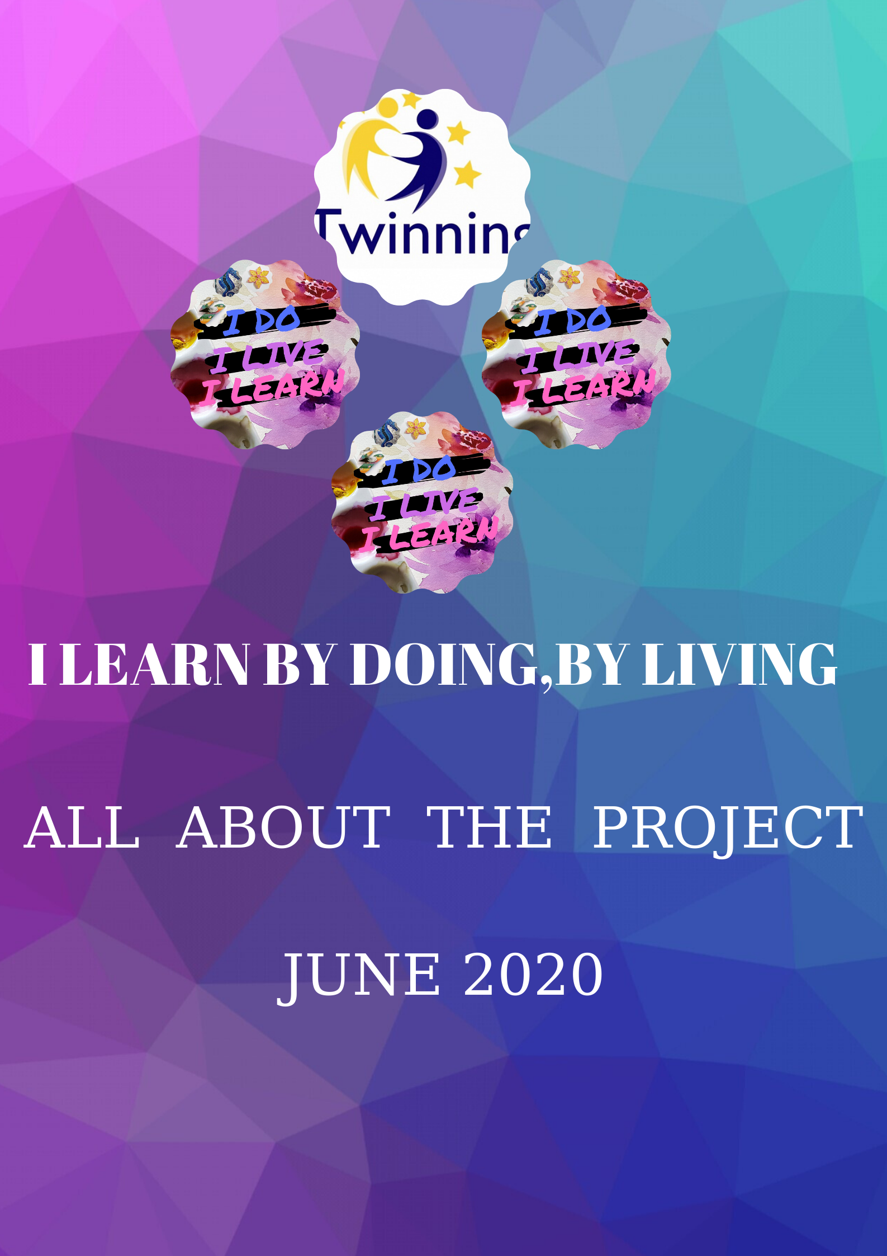
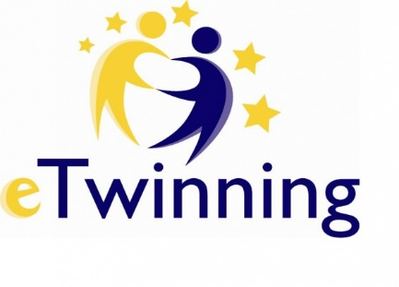
1. GENERAL INFORMATION
1.1. Informatıon of the project
1.2. Teacher Introduction
Teacher Connecting Information
1.3. School Introduction
We Are On Map
School Adress and Web Page
1.4. WEB 2.0 TOOLS used in the Project
Netiquette in the project
1.5.Commınıcatıon and collaboratıon

2. DISSEMINATION

2.1.Our Logo
Our Poster
Our Slogan
2.2.Proje Blog
Project News
2.3. Pre-Test
Survey
Final Evaluation
Brochure

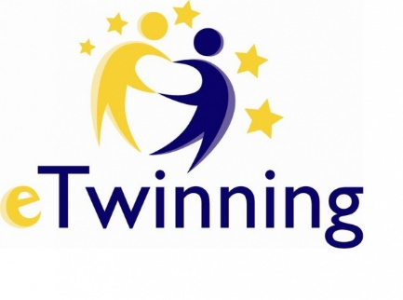
3. OUR WORKSHOPS AND E BOOK
3.1. Krıgami workshops
>>Krigami e book
3.2. Creating a wall ornament
>>Creating a wall ornament e book
3.3. Quiling workshop
>> Quiling e-book
3.4.Mosaic workshop
>>Mosaic e book
3.5.Origami workshop
>>Origami e book
3.6.Making musical instruments
>>Making musical instruments e book

4. COLLABORATIVE WORKS

4.1.Codeweek (5-20 October 2019)
Safety Internet Day (11 February 2020)
E Twinning Day (9 May 2020
4.2.New Year Cards
Our Acrostic Poem
Coronovirus diaries
5. EPILOGUE...

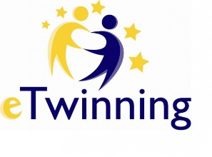
1. GENERAL INFORMATION
BANU GÜNGÖREN-İNCİRAĞACI PRİMARY SCHOOL/FİNİKE-ANTALYA
1.1 INTRODUCTION
Our 'I Learn by doing, by living' project 2019-2020 academic year
Participation is a project of four countries. (Turkey, Ukraine, Romania and Poland)
The start date of our project is September 30, 2019 and the end date is June 2020 The purpose of our project is to enable our students to learn what they have learned by transforming them into life skills. Our schools and classes in the project have become workshops on their own scale. Even because of the coronovirus, our houses have turned into workshops.
(Due to the coronovirus, we have sent three of our workshops to our students by sending videos and pictures from WHATSAPP groups at home).
We completed our project with the logic that distance education can be a learning environment anywhere.
DOROTA JANUSZEWSKA ZESPÓŁ PUBLİCZNYCH PLACÓWEK OŚWİATOWYCH W SAMBORCU SAMBORZEC, POLONYA
1.2 TEACHER INTRODUCTION
The following teachers took part in the I learn by doing, by living project:
- Derya Ceylan - Sincan Şehit Abdullah Büyüksoy Bilim Ve Sanat Merkezi, Sincan, Turcja.
- Banu Güngören - İncirağacı İlkokulu-Finike/Antalya, Turcja.
- Eren BALOĞLU/M.Zİraat Odası İ.O./Toroslar-MERSİN, Turcja.
- Dorota Januszewska – Zespół Publicznych Placówek oświatowych w Samborcu.
- Ewelina Wielgus - Zespół Publicznych Placówek oświatowych w Samborcu.
- Tülün Tekeli Ziraat Odası İlkokulu, Toroslar, Turcja.
- Meral Kocaibiş Kartal Soğanlık İlkokulu, Kartal, Turcja.
- Arzu Guvenenler Umurbey ilkokulu, Lapseki, Turcja.
- Pınar Yücel Ziraat Odası İlkokulu, Toroslar, Turcja.
- Demet Gür (Founderl) Ziraat Odası İlkokulu, Toroslar, Turcja,
- Hüseyin Emre KılıçHüseyin Manavgat Bilim Sanat Merkezi, Manavgat, Turcja.
- Oana Maria Damir GRADINITA CU PROGRAM PRELUNGIT NR. 1 IASI, ROMANIA, Iași, Rumunia.
- Dilek Kozak FATİH İLKOKULU, Milas, Turcja.
- YASEMİN KÖKSAL ŞEHİT METİN ARSLAN İLKOKULU, Sarıkaya, Turcja.
- Fatma Boyraz Barbaros ilkokulu, Yumurtalık, Turcja.
- Zeynep Palalı Ziraat Odası İlkokulu, Toroslar, Turcja.
TEACHER CONNECTİNG INFORMATION
In this section of the project, the teacher's podcasts for their schools and their abilities and email address, their phone numbers for better communication with each other, working days and hours, and days off from school.

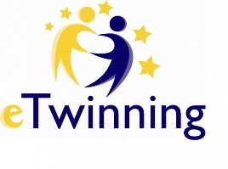
OANA DAMIR GRADINITA CU PROGRAM PRELUNGIT NR. 1 IASI, ROMANIA
1.3. SCHOOL INTRODUCTION
It is very interesting to situate the children and the schools that are taking part in the project. That is why, we always use a map to do this activity. Apart from that, we usually use google Earth to see and imagine how is other children towns. Children really like to know how is their towns and their schools.
We are on map
In the project, we put a little introduction about how our school is. Our goal was to get to know each other's school.It was to satisfy our students' curiosity towards different cultures.So we got to know each other better.
DEMET GÜR ZİRAAT ODASI PRİMARY SCHOOL 2/C CLASS
1.4.WEB 2.0 TOOLS USED İN THE PROJECT
We used many types of web2.0 tools in our project. We helped each other with usage by introducing new web2 tools to each other by writing the tools we use. web2.0 tools provide us with a lot of convenience, we save time and space, we can decorate, add music and make it visually and aurally impressive, we can also provide motivation with fun content. New web2 tools, which we do not know every day, come out and make our lives easier, and we are informed when we share them with each other. We are expanding their horizons by introducing this rich and fun world to our students.
NETIQUETTE IN THE PROJECT:
Internet ethics are rules that define acceptable or unacceptable behavior in the internet environment. We know the rules of using the internet and social media. While conducting our eTwinning projects, we need to pay attention to these rules. At the beginning of the project, we created a page called Internet ethics to remind them of these rules.
TÜLÜN TEKELİ / ZİRAAT ODASI PRİMARY SCHOOL 2/G CLASS
1.5.COMMUNİCATİON AND COLLABORATİON
It is not easy to create, design and carry out a project. But within the challenge, communication and participation of the members is essential. At the beginning of the course, the project administrators met and exchanged several emails to shape the project. Then we shared the idea and shaped the project.
During the project, collaboration between the teachers has been constant, close and creative. It has been satisfactory to have participated in all phases of the project since the presentation of the city / center / teaching staff that was made in the first month; as in the design and voting activities of the logo; workshops; acrostic poem; exhibition; creation of ebooks and so on. Finally, all the teachers and students participated in the different ways of evaluation.
Thanks to the advantages of eTwinning platform (videoconferences in eTwinning Live, Chat, Events...) and technology our work has been easier. The TwinSpace tools have also been very useful (Pages, Dashboard) to organise the work and related to that, we have create “task” page,
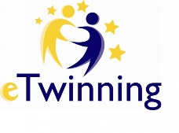
that has been very useful to our organisation.
Apart from that, we understand that collaboration is not only to share it the work, it is more, we need to collaborate to create something, in other words, all teachers implication is essential to get the final aim. To do that, we share all the videos and photos, we comment everything in the meetings and so on.
2. DISSEMINATION
SEVİL ŞEHLEVENT BABA_ MERSİN ZİRAAT ODASI PRİMARY SCHOOL_ KİNDERGARTEN CLASS
2.1.STORY OF OUR LOGO
The project management team prepared an analysis for our needs at classes the new decided about how to make learners active during our activities in the class and even out of the class. We prepared the action plan for the project. On November 2019, we all had to prepare the project logo about how to make learners active.
We shared objectives of our plan and working process with our colleagues, pupils and parents. We shared information about the project idea, the content, and plan and how they would contribute activities with their pupils. Each team and teachers have started to give information about Web 2.0 tools to create a logo which is going to be the main and informative icon to tell about the content of our project.
Each team prepared a logo with their students, parents. Then we shared a link for the logos to be voted with participation of our partners and even some of us shared the link with many more teachers, people via social media. The results of 421 votes were like this; https://twinspace.etwinning.net/files/collabspace/6/16/816/94816/files/c2d3df37.xls
THE POSTER OF VISIBILITY
The project management team prepared an analysis for our needs at classes the new decided about how to make learners active during our activities in the class and even out of the class. We prepared the action plan for the project. On November 2019, we started learning by doing planned actions and one of them and funny one was preparing “poster” to make our aim visible.
We shared objectives of our plan and working process with our colleagues, pupils and parents. We shared information about the project idea, the content, and plan and how they would contribute activities with their pupils. Each team and teachers have started to give information about Web 2.0 tools to create a poster to inform many more people about our intent.
Each team prepared one or more posters with their students, parents. Then we shared a link for the posters to be voted with participation of our partners and even some of us shared the link with many more teachers, on our school websites, official accounts and people via social media accounts.
“I do I live I learn” poster were voted with the most likes;
https://twinspace.etwinning.net/94816/pages/page/699993
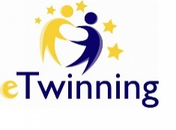
YOU CAN HEAR OUR VOICE WITH THE MOST MEANINGFUL SLOGAN EVER!
There were so many creative designs helping people to know about our project. The project management team prepared an analysis for our needs at classes; we made agreement about how to make learners active during our activities in the class and even out of the class. We prepared the action plan for the project. On November 2019, we started learning by doing planned actions and one of them and funny one was preparing “slogan” to make more people hear our voice with the most and collaborative ones.
We shared objectives of our plan and working process with our colleagues, pupils and parents. We shared information about the project idea, the content, and plan and how they would contribute activities with their pupils. Each team and teachers have started to give information about Web 2.0 tools to create a poster to inform many more people about our intent.
Each team prepared one or more slogans with their students, parents. Then we shared a link for the posters to be voted with participation of our partners via form. We shared the favourite ones with teachers, on our school websites, official accounts and people via social media accounts.
OUR SLOGAN VOTING RESULTS
We both learn and enjoy by doing and living
The Vote for slogan has just resulted. Thanks a lot for your great contributions.
The Winner is :Dilek KOZAK / Fatih İlkokulu / Milas https://twinspace.etwinning.net/94816/pages/page/700008

MARAVELA JANETA SİMONA/ ȘCOALA GİMNAZİALĂ NR. 22, GALAȚİ
2.2 PROJECT BLOG
The project blog was created to share and disseminate our knowledge and achievements about the project. We had a rich content blog with the share of our partners.
PROJECT NEWS
One of the dissemination methods we use to share what we do about the project is News.
We shared our news about the project in EBA, on our schools' websites, on our Instagram, Facebook and Twitter accounts.

TÜLÜN TEKELİ/ ZİRAAT ODASI PRIMARY SCHOOL -2/G CLASS
2.3. PRE -TEST:
Most of our students who participated in our project were small. Therefore, we would need parents' support. We applied a parent questionnaire to get more information about the parents. We shaped our project according to the answers from the parents. We shared the survey results on the related page of our project.
https://twinspace.etwinning.net/94816/pages/page/776515
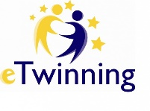
SURVEY:
While continuing our project, our schools have been on holiday because of the Covid-19 outbreak. For this reason, we were not able to do the workshops that we had to practice in March, April and May. We organized a survey among the teachers participating in the project. We asked if we can get mosaic, origami and musical instruments works from our homes. We continued the project with the joint decision of the teachers. Krona could not stop us and we have completed all our work.
https://twinspace.etwinning.net/94816/pages/page/956441
FINAL EVALUATION:
STUDENT EVALUATION
In our '' I learn By Doing, By Living '' project, we had six different workshops aimed at improving our students' hand skills. At the end of the project, we applied a 7-item questionnaire to see what studies they like to do and to get their opinions on the effect on learning. 190 students participated in this survey. According to the answers of the respondents, the questions and their percentages are as follows.
1) Do you like to make krigami? 160 people answered yes, 18 sometimes, and 12 answered no.
2) Do you like making wall ornaments? 169 people answered yes, 16 sometimes, and 5 answered no.
3) Are you having fun while quiling? In the question153 people answered yes, 30 people sometimes, and 7 people answered no.
4) Is it fun to make a mosaic? 160 people answered yes, 22 sometimes, and 16 answered no.
5) Did Origami improve dexterity? 154 people answered yes, 21 sometimes, and 15 answered no.
6) Was it fun to make music with your musical instrument? 174 people answered yes, 11 sometimes, and 5 answered no.
7) Did this project help you learn? 170 people answered yes, 11 sometimes, and 9 answered no.
TEACHER EVALUATION
In our project, we organized six different workshops aimed at improving our students' hand skills. At the end of the project, we applied a 5-item questionnaire to see if the teachers participating in the project had difficulties applying the workshops and to evaluate themselves and their students in the project. 21 teachers participated in this research. According to the answers of the participants, the questions and their percentages are as follows.
1) Have I taken part actively in the project? 18 people yes, 3 people sometimes answered.
2) Have I adapted the lesson to children interest and needs? 20 people yes, 1 person sometimes answered.
3) Have the activities I prepared helped to increase children’s participation? 21 people answered yes.
4) Has the technology helped to increase children’s participation? 19 people yes, 2 people sometimes answered.
5) Everything has worked properly? If not what should I change? 21 people answered yes.
https://twinspace.etwinning.net/94816/pages/page/970363
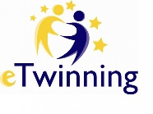
BROCHURE
We prepared a brochure introducing our project. Our brochure; We have the start date of the project, the processing plan, the introduction of the partners, the applied workshops and our purpose. We used the Canva web2 tool for the brochure work.
https://twinspace.etwinning.net/94816/pages/page/977643

3. OUR WORKSHOPS AND E BOOK
ZEYNEP PALALI /ZİRAAT ODASI PRİMARY SCHOOL 2/H CLASS
3.1 KRIGAMI WORKSHOP
Paper design activities are examples of schematic learning through repetitive actions. Modeling and symmetry are the most important concepts.
In Krigami studies, children develop feelings of communication, observation and cooperation with other people.
When children produce a product with their own work, they meet the needs of emotional satisfaction and acceptance by others.
With the Krigami workshop, the children prepared the winter season theme and new year cards. They shared it with their friends. They worked cooperatively.
The children had a lot of fun in this study they made with their own efforts.
The purpose of this workshop was to create an artistic product. To increase the self-confidence by giving children the chance to express their thoughts and feelings in a study.
All project partners published presentations on twin domain pages and used Web.2 tools.
The summary of the Krigami workshop was to create an ebook containing all relevant project sections
https://www.storyjumper.com/book/read/85145215/5ee3678cac45e
PINAR YUCEL-ZİRAAT ODASI PRIMARY SCHOOL -2/F CLASS
3.2.CREATING A WALL ORNAMENT
Our teachers and students have prepared their own learning materials '' wall ornaments '' that lead to permanent learning experiences.Our wall ornament theme was "Nature".Easily accessible, inexpensive, ready-to-nature, natural and waste materials were used in wall decoration.While doing this activity, it was observed that children's imaginations expanded, their creativity and self-confidence increased, they had fun, and enjoyed their work.It was determined that the students' interest and desire towards the lessons increased and their feelings of cooperation and sharing improved among the students by using activities and materials.The passive students were enabled to become more active and to realize their talents by participating in the activities.Our project partners published their works on their pages.Web 2 tools were used.E-book was created with all the work done.I thank my project founders and partners.Thanks to my project founders and partners.
https://www.storyjumper.com/book/read/84942535/5edd31099be44
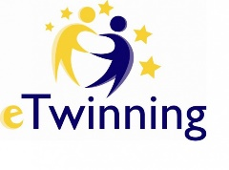
EMRE KILIÇ / MANAVGAT – BİLSEM
3.3 QUILING WORKSHOP
Paper design activities are examples of schematic learning through repetitive actions. Children develop communication, observation and cooperation with other people, and feelings of cooperation.
When children produce a product with their own work, they meet the needs of being emotionally satisfied and accepted by others.
The purpose of these workshop was creating an artistic product enhances their self-confidence by giving children the chance to express their thoughts and feelings in a work.All project partners have posted presentations on twinspace pages and have used Web.2 tools.
The summary of the quiling workshop was to create an e-book with all project parts involved.
https://www.storyjumper.com/book/read/84777755/5ed81a5d36e57

EREN BALOĞLU/ZİRAAT ODASI PRİMARY SCHOOL KİNDERGARTEN D CLASS

3.5. ORIGAMI WORKSHOP
Origami design activities are examples of schematic learning with repetitive actions. Modeling and symmetry are the most important concepts.
In origami works, children develop feelings of communication, observation and cooperation with other people.
When children produce a product with their own work, they meet the needs of emotional satisfaction and acceptance by others.
Behavioral skills of Origami,
Learning together,
Preparing the ground to learn geometry,
Development of cognitive and motor muscles,
It has benefits such as increasing mathematical skills.
With the Origami workshop, children prepared different products. They shared this with their friends. They worked together.
The children had a lot of fun in this study they did with their own efforts.
The aim of this workshop was to create an artistic product. To increase self-confidence by giving children the chance to express their thoughts and feelings in a study.
All project partners published presentations on double domain pages and used Web.2 tools.
The summary of the Origami workshop was to create an ebook containing all relevant project sections.
https://www.storyjumper.com/book/read/84766665/5ed8cf708c46d
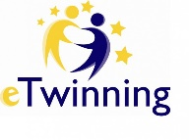
GÖNÜL DOĞAN- ZÜBEYDE HANIM İLKOKULU/AZİZİYE-ERZURUM
3.4 MOSAIC WORKSHOP
Mosaic works are painting works formed by bringing small pieces of various colors together.
We have made various studies by adapting them to the levels of our students using many different tools.
Friends who took a break from education during the pandemic period showed that our students can create products by staying at home by participating in these activities.
In these studies, besides the development of the finger muscles of our children, we have also added activities for laying and painting in a certain order.
An e-book about mosaic works has been created.
https://www.storyjumper.com/book/showframe/84893415/5edab3889d913#page/1

EWELİNA WİELGUS - WESOŁE JABŁUSZKO KİNDERGARTEN İN SAMBORCU - POLAND
3.6 THE PROCESS OF CREATING MUSIC WORKSHOPS.
The purpose of these workshops was to collect retkling waste and then make musical instruments out of them. The children used these instruments to learn but also to play. These workshops contributed to the development of imagination and ingenuity that we can do something out of unnecessary things. Musical instruments were also used to record the song by project participants. The most important thing in this workshop was that we could do things from other things.All project partners have posted presentations on twinspace pages and have used Web.2 tools. The summary of the music workshop was to create an e-book with all project parts involved.
https://www.storyjumper.com/book/read/84942105/5edd44a940f7c
4. COLLABORATIVE WORKS
ARZU GÜVENENLER/ UMURBEY PRIMARY SCHOOL-ÇANAKKALE
4.1 CODEWEEK-SAFETY INTERNET DAY-E-TWINNING DAY
CODEWEEK(5-20 OCTOBER 2019) EU Code week is a grassroots initiative which aims to bring coding and digital literacy to everybody in a fun and engaging way. Learning to code helps us make sense of the rapidly changing world around us.
So various topics were held for each age group.B y the agency of code week students had fun and developed their problem solving skills while stepping into the digital world. Also this activity helped our students gain systematic thinking skills. At the end of the activity students saw other schools' activities. They understood that coding is a unlimited world.
SAFETY INTERNET DAY (11 FEBRUARY 2020 ) Safety Internet Day is an international event taking place in February every year which promotes a safer and more responsible use of online technology across the world.
This year's Safer Internet Day celebrations were taking place on 11st February.Digital world does
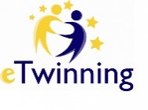
not recognise any borders and therefore we needed to explain to our students how to use online technology and mobile phones.
First of all teachers gave seminars about safety internet. Then we prepared different activities for our students.Drawing pictures,colouring,posters,logos...
E-TWINNING DAY ( 9 MAY 2020 )E-Twinning provides an online platform for schools to communicate,collaborate,develop projects and share in Europe.
On May we celebrated e-twinning Day. To highlight the importance of working and achieving together,teachers and students created their own ideas. Then they prepared and shared their posters,pictures,photos...

5. EPILOGUE...
Since we were born, we are already doing the learning by living by making it the easiest method of learning.
For this, we developed our project using this learning method.
Our students lived while doing workshops, had fun while living, learned while having fun.
We, the teachers, talked, discussed, talked, corresponded, decided on what we could apply and agreed. Experienced teachers helped new etwinners.
They learned by doing and living.

